Part A Linear equations

Question 1

  - For the simultaneous linear equations given below, you are to plot and construct straight- line graphs in the Cartesian plane template provided. Be sure to carefully label each of the graphs.

    - y = x

    - y = -3x – 8

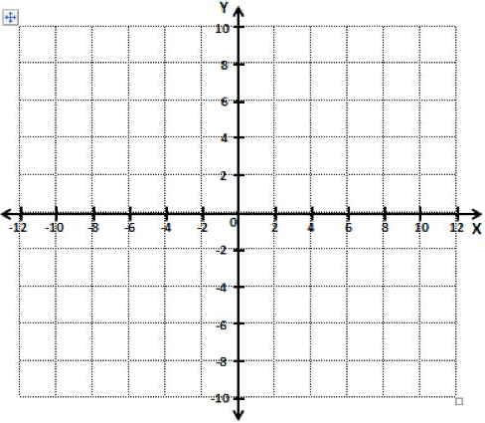

  - Next, label the intersection point for the two straight lines you constructed in part (a), being sure to specify the coordinates in the format (x, y).

  - Using the techniques of elimination and substitution, solve for ‘x’ and ‘y’ in the simultaneous linear equations given in part (a).

Workings and answer

6

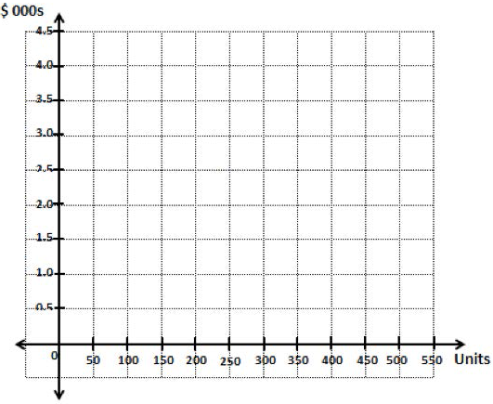

Question 2
- Given the information below, you are to use the algebraic method to determine the break- even unit sales and dollars revenue.

Selling price per unit = $3.00 Variable cost per unit = $1.80 Total fixed costs = $480 Workings and answer

- Using the information given in part (a) of this question, you are to use the graphic method to determine the break-even unit sales and dollars revenue.

Be sure to carefully label the straight lines for the revenue and cost functions, as well as the break-even point. The break-even point must be indicated in the format of (Units, $).

7

